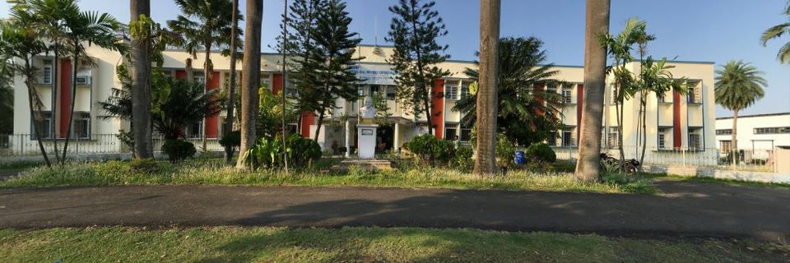

|  |
| --- |
|  |
| MODULE ?  Maintenance and Troubleshooting |
| August 9, 2023  NSIC |



Maintenance:

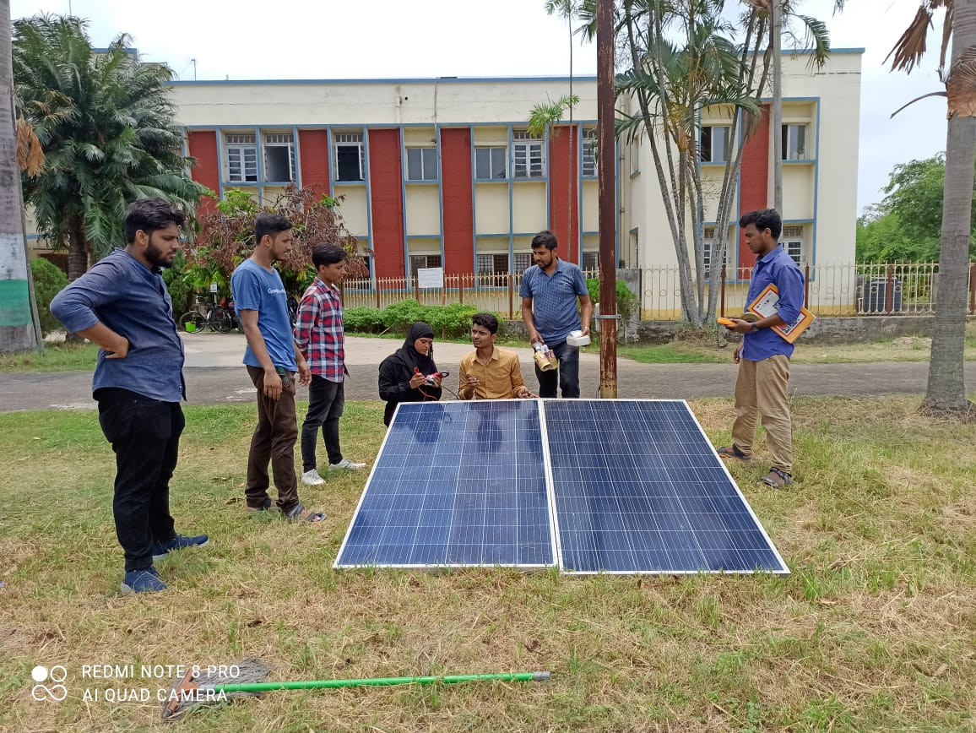Regular solar panel maintenance is crucial for optimal performance. Clean panels from dirt and debris using a soft brush or water. Ensure panels are free from shading caused by trees or obstructions. Inspect for physical damage and address issues promptly. Check wiring, connectors, and junction boxes for wear or corrosion. Monitor the inverter's performance and weatherproofing. Adjust panel angle seasonally for maximum sunlight exposure. Use monitoring systems to track energy output. Schedule professional inspections annually. Keep records of maintenance activities for reference. Following these steps enhances efficiency, prolongs panel life, and maintains system reliability.

Precautions and Preventive Steps:

1. Parallel Connection of SPV Modules:

~ Multiple solar panels are linked side by side (in parallel).

~ Panel output voltage stays below 25 Volts in normal sunlight.

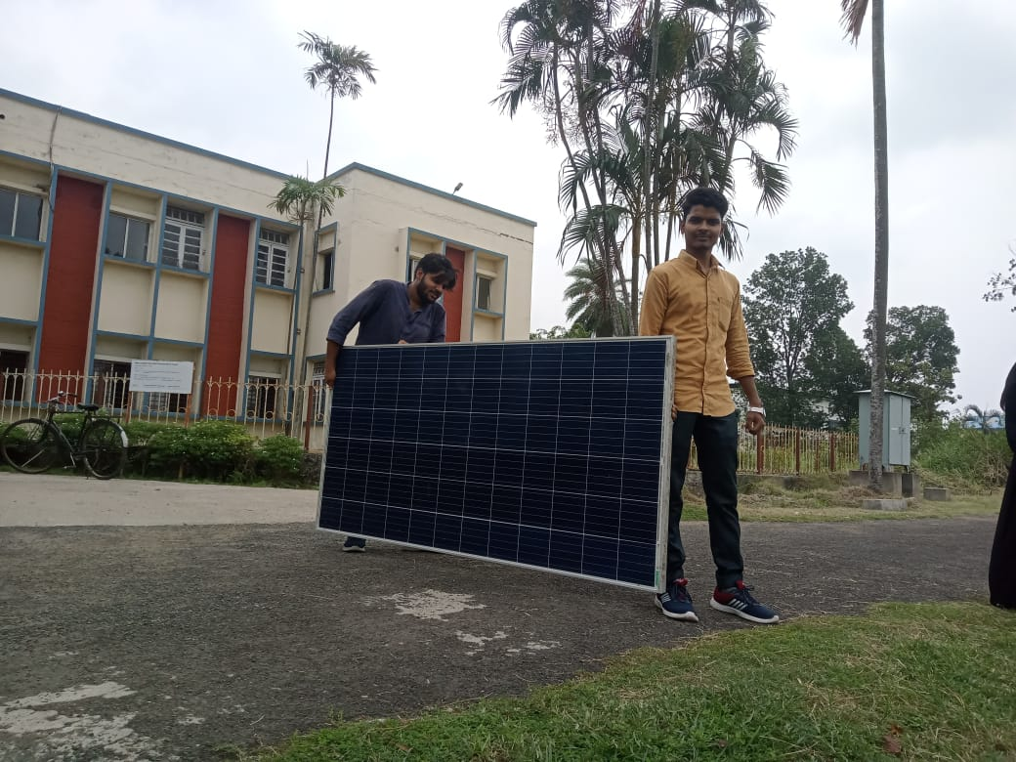~ For a 12V system/module configuration.

2. Proper Connection with Crimped Wires:

~ All connections are correctly secured using crimped Red (+ve) and Black

(-ve) wires.

~ These wires are provided by the manufacturer to prevent incorrect polarity.

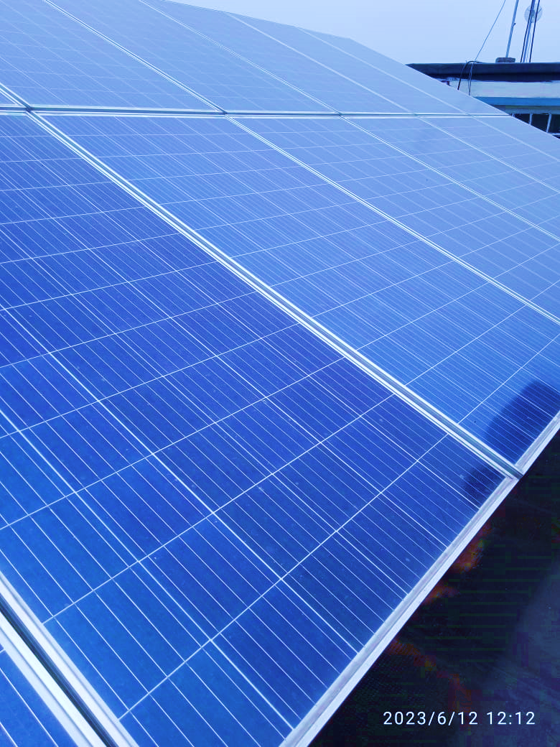3. Unchanged Charge Controller Fuse Rating:

~ The charge controller's fuse rating remains as specified.

~ It safeguards the system against overcurrent.

4. South-Facing Installation with Tilt Angle:

~ Solar panel faces the SOUTH direction.

~ It is installed at the right 'Angle of tilt' for optimal sunlight capture.

5. Shadow-Free Panel for Maximum Power:

~ The solar panel remains free from shadows at all times.

~ Ensures maximum power generation.

6. Protection Against Damage and Theft:

~ Panels are safeguarded from vandalism and accidental damage.

~ Fencing is used if panels are on the ground, avoiding shadows.

7. Battery Bank Placement and Ventilation:

~ Battery bank is raised and isolated from the ground.

~ It's situated in a well-ventilated area with enough overhead space.

8. Sequential Connection and Disconnection:

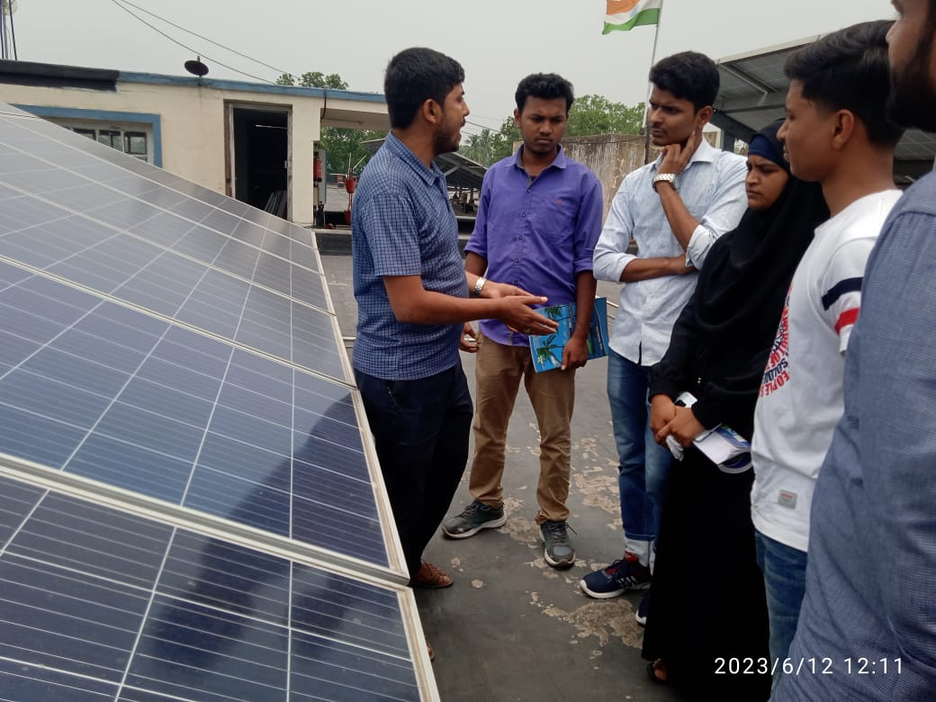~ Battery bank connects first, followed by the panel and then the load.

~ For disconnection, the order is reversed.

9. Avoid Battery Terminal Shorting:

~ Prevent shorting battery terminals, which leads to sparks and fire.

~ Connect cables to the charge controller end first, then the battery.

10. No Direct Load Connection to Panel:

~ Don't connect the load directly to the panel.

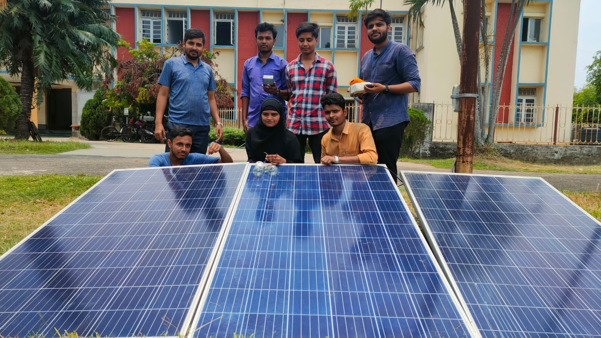~ Voltage mismatch can damage equipment.

11. Blocking Diode for Reverse Polarity:

~ A blocking diode is added at the array output.

~ Guards against reverse polarity issues.

12. Ensure Uninterrupted Sunlight:

~ Place solar modules where they receive full direct sunlight throughout the day.

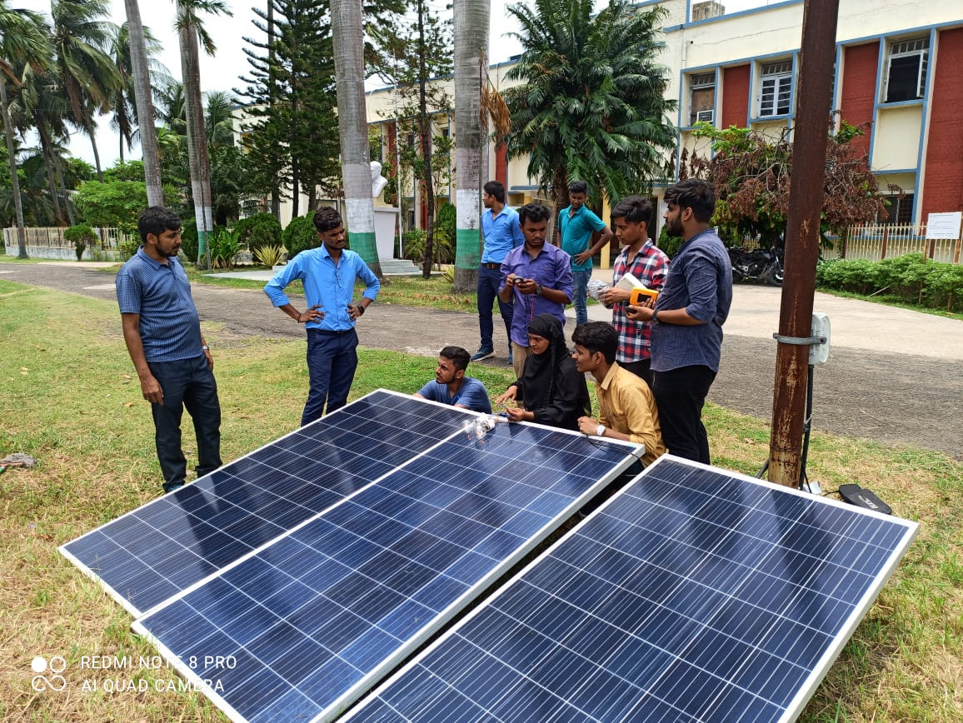

13. Indicator and Efficient Charging:

~ Green charge controller indicator shows charging status.

~ To optimize charging, ensure direct sunlight exposure for most of the day.

14. Light, Not Heat, Generates Energy:

~ Energy is produced by light, not heat.

~ Panels should receive unobstructed sunlight without shading for effective power generation.

Troubleshooting:

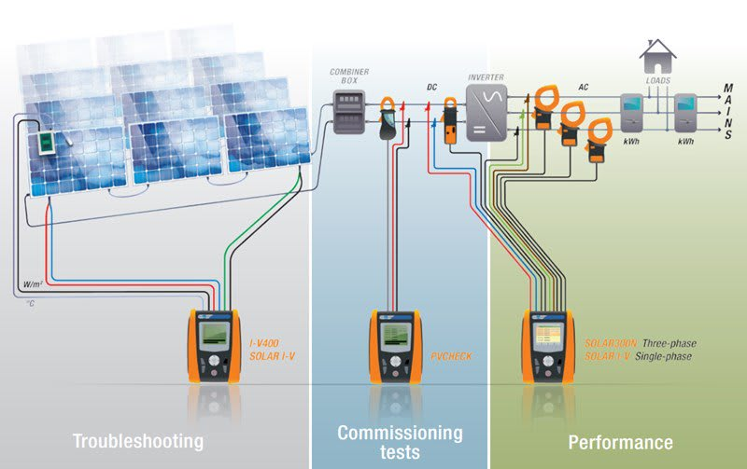The solar power system is usually dependable, but occasional issues may arise where it can't run devices. To troubleshoot, start by checking the battery voltage. If it's right as shown on the charge controller, look at the inverter or the switch between inverter and load. If those are fine, examine the battery's electrolyte specific gravity. This step-by-step process helps identify and fix the problem.

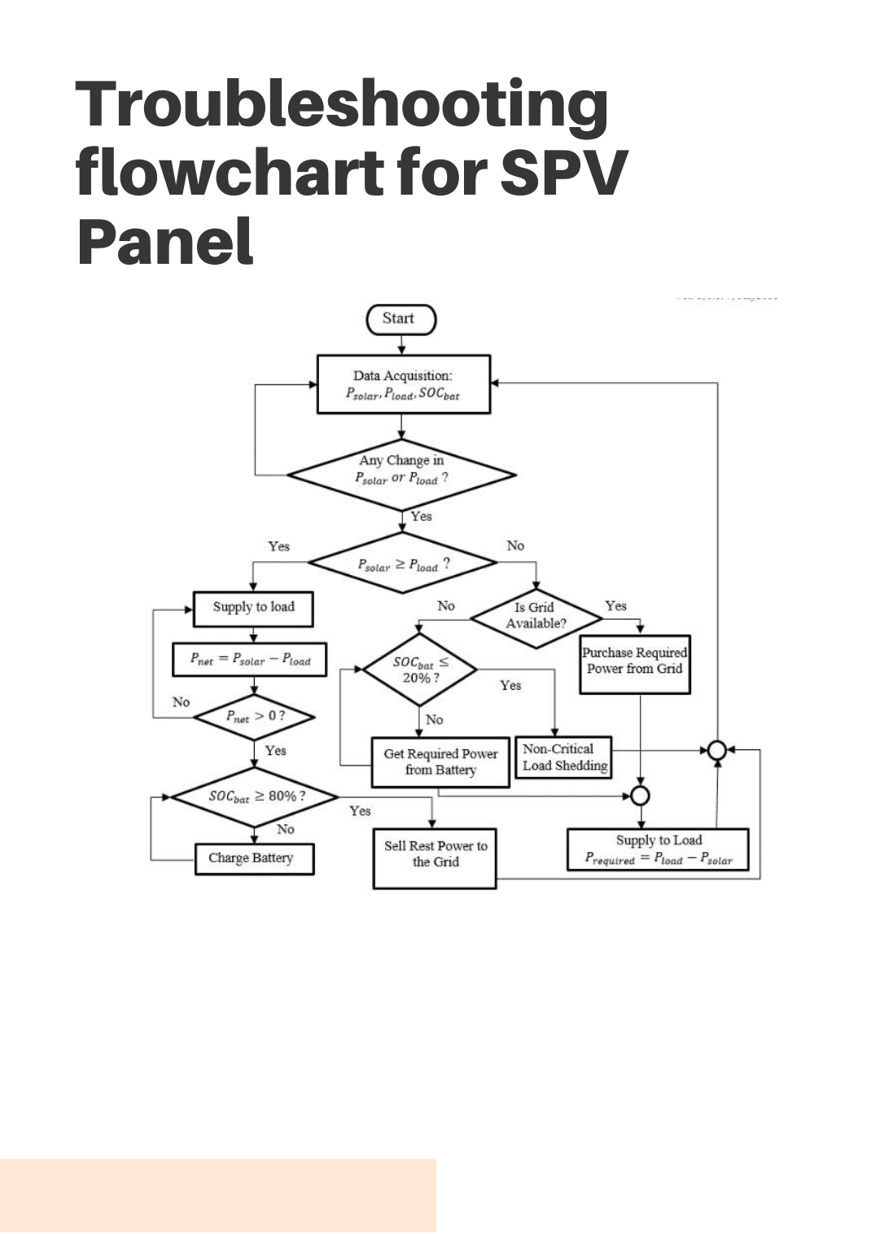

Causes:

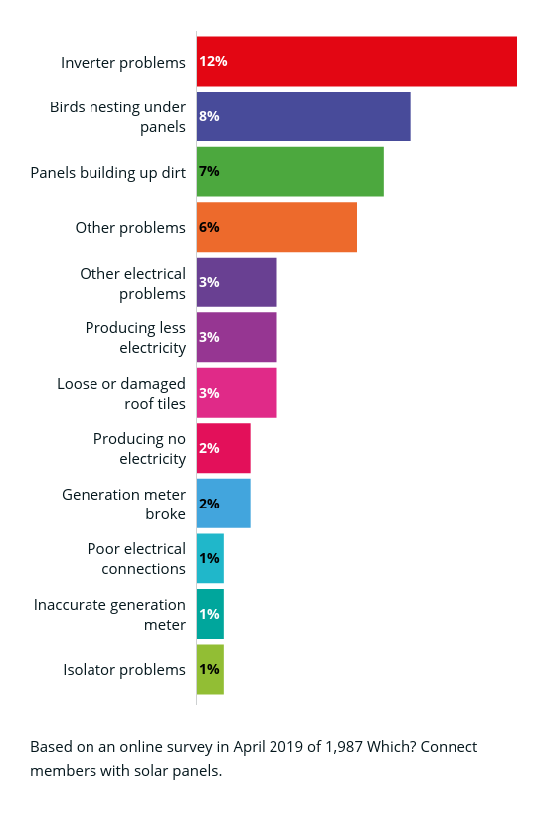a) Specific Gravity and Battery Check:

If the battery's specific gravity is above 1.2 or the recommended level, the battery is likely fine.

Test the load equipment by connecting it directly to the battery. If it works, the issue may be with the Charge Controller.

If the problem persists, follow troubleshooting steps in the provided manual or contact the manufacturer.

b) Low Specific Gravity and BATT/LOW LED:

Low specific gravity and a glowing BATT/LOW (Red) LED indicate potential issues.

The load might be drawing excessive current, leading to battery discharge and load tripping.

Check load equipment for defects and replace faulty components.

Inspect the SPV Panel's performance. Measure module voltage and current individually when there's bright sunshine.

Verify the blocking diode's status. It can fail in short or open circuits. Test it by isolating it and checking for voltage and current behavior.

By following these steps, you can troubleshoot problems related to battery, load, SPV Panel, and blocking diode effectively.

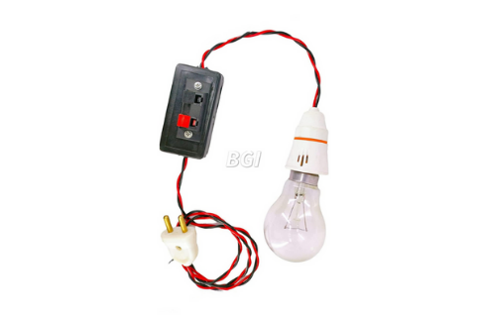

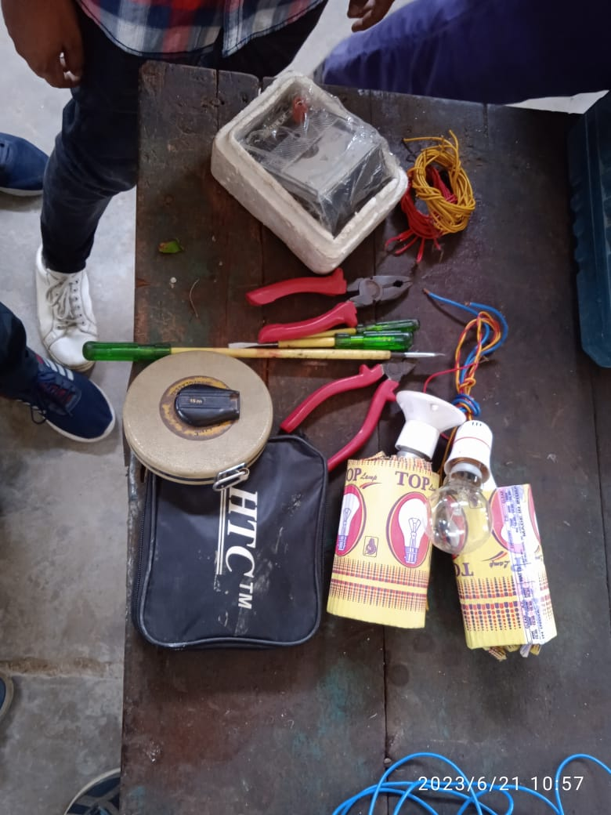Testing Equipments:

1. Test lamps

2. Prototype Motors

3. Multimeters

4. Analog Ammeters

5. Analog Voltmeters

6. Digital AHO/Clamp meters

7. Testing kits

8. Meggers

9. Lux Meters

10. Angle Deflector and MPPT systems

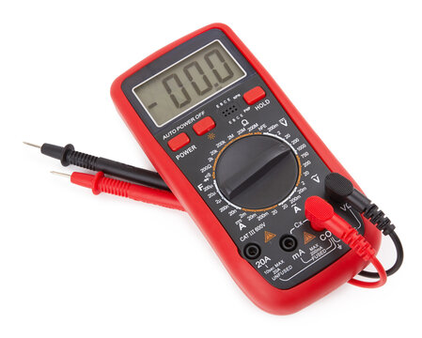11. Screw Drivers, other Accessories

12. Relay kits

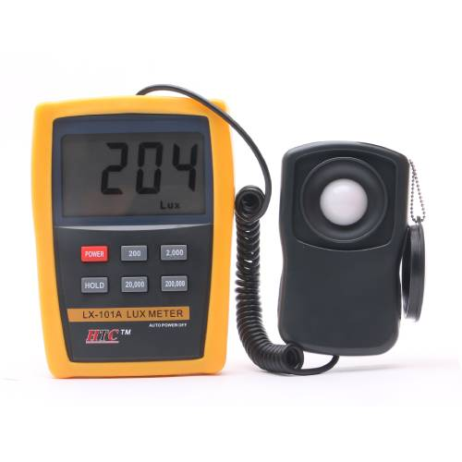13. Earth Testers

14. Induction Motors

15. Analog Energy meters

16. Digital Energy meters

17. Measuring Tapes

18. Drivers and Systems.

19. Test leads

20. Wire Conduits , cutters and gauge conversion meters.

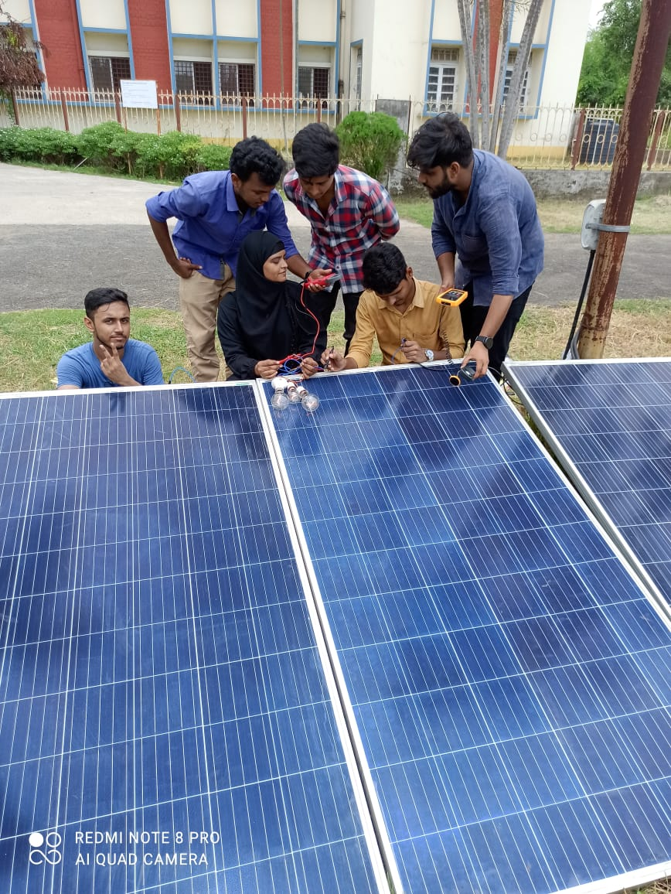

CONCLUSION:

Electrifying distant rural areas can be expensive. Off-grid PV systems are a viable solution for high-cost electrification scenarios. Grid-tied systems suit urban settings,

while off-grid is apt for unelectrified or independent energy needs. This paper outlines designing an off-grid PV system for EIU's bus shelter, accommodating essential equipment like WIFI, charging points, and lighting. The methodology applies beyond bus shelters. Economic details are

omitted due to varied market options. System capacity identification allows selecting equipment based on financial preferences.

